Associated Mobile Fauna (Optional)



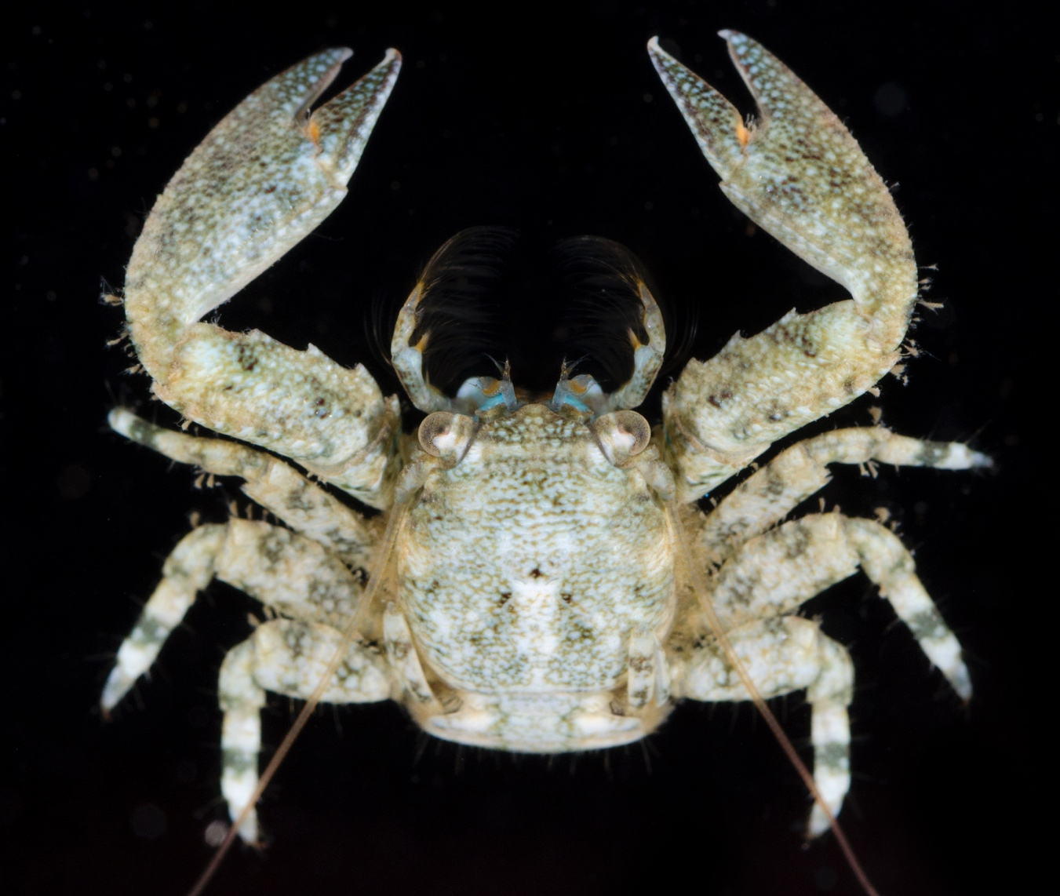

How to cite this work: MarineGEO Fouling Community Monitoring Protocol. (2021) Janiak, Dean, Tennenbaum Marine Observatories Network, MarineGEO, Smithsonian Institution. https://doi.org/10.25573/serc.14510649.v1





Introduction

Despite a lengthy history of research done on fouling communities, there exists very little data on the associated mobile fauna (non-tube building) found within these communities. Here we provide an optional auxiliary protocol to sampling this group of species in a standardized way.

Measured Parameters:

* Mobile fauna abundance and diversity



Requirements

Personnel: 1-2 people

Estimated Total Time Per Location (*n* = 3 sites per habitat):

Lab work: 1-2 people x 5 days

Data entry: 1 person x <1 days

\*Estimated times will vary by site and conditions

Replication: At least three (3) sites per habitat, the number of habitats is decided by the partner site.

Materials:

* Forceps
* Dissecting microscope
* Data sheets



Methods

Fully review this and any additional protocols necessary for the sampling excursion. Address any questions or concerns to [marinegeo-protocols@si.edu](mailto:marinegeo@si.edu) before beginning this protocol.

1. Please see previous protocols for methodology on how to sample mobile fauna from communities. The following steps occur after samples have been collected.
2. Pour contents of a single vial into a dish and sort all complete species or at least those with the anterior portion intact. Remove and discard all non-living material. Identify and count all mobile fauna. All species should be identified to the possible taxonomic level. However, if this is not possible, place species into lowest taxonomic categories (amphipods, polychaetes, crabs, shrimp, etc.). We recommend that each new species at least be given a unique identifier. This is important to estimate richness and diversity of the mobile community. Photos can also be taken of unknown species and shared with the network. *Be sure to ignore any tube-building fauna (e.g. corophiid amphipods, sabellid and or serpulid* *polychaetes).*
3. For counting purposes, only record species that are complete or at least have the anterior region present (“head-counts”). For mangled or incomplete species without the anterior region, do not count and discard. For gastropods, make sure the animal is present either by looking for the foot or crushing the shell.
4. Once enumerated, samples should be retained for potential further studies.



Data Submission

1. Scan the completed field data sheets and save both paper and electronic versions locally. We do not require you to submit the scanned forms.
2. Enter data into the provided data entry template. Each template is an Excel spreadsheet. Please provide as much protocol and sample metadata as possible. Use the “notes” columns to provide additional information or context if a relevant column doesn’t already exist, rather than renaming or creating columns.
3. Use our online submission portal to upload the Excel Spreadsheet: <https://marinegeo.github.io/data-submission>
4. Contact us if you have any questions: [marinegeo-protocols@si.edu](mailto:marinegeo@si.edu)